


Korea Lunar Exploration Program
DTNPL EGSE Technical Description

Date: 28 Dec. 2017 | Doc. No: KPLO-D0-550-301  Issue: 1.0  Total page: 20

Superseding Revised

Prepared By:  Jong-Cheon Kim Date  DTN SBC EGSE Engineer, Lumir  Dae-Soo Oh Date  DTN SBC Engineer, Lumir |  | Kyung-Rak Lee Date  DTN Payload Engineer, ETRI
Reviewed By:  Jin-Ho Jo Date  DTN System Engineer, ETRI |  | Sin-Ae Ji Date  Proximity-1 System Engineer, ETRI
Sang-Man Moon Date  RLE KPLO Electrical System, KARI |  | Hyun-Jin Shin Date  RLE KPLO Mechanical System, KARI
Approval Signature:  Byoung-Sun Lee Date  DTN Project Leader, ETRI |  | Il-Young Kim Date  RLE KPLO Product Assurance, KARI
Seong-Bin Lim Date  Head, Lunar Exploration System Team, KARI |  | Seok-Weon Choi Date  Director, Lunar Exploration Program Office, KARI

Original CDMO Release__________________

Revision History
Version | Author(s) |  | Date | Description
0.1 | Jong-Cheon Kim |  | 2017. 12. 28 | Draft

Revision/Change Records
Version | Date | Revision/Change Description | Pages
0.1 | 2017. 12. 28 | Initial | All

Documents Tree

Contents

1. Introduction 7
1.1. Purpose and Scope 7
1.2. Applicable Documents 7
1.2.1. ETRI Documents 7
1.2.2. Other Documents 7
1.3. Abbreviations 7
2. Overview of KPLO DTN 9
2.1. DTN and Space Communications 9
2.2. Mission of DTN Operation 9
2.3. DTN Configurations 9
2.4. Communication Nodes 10
2.4.1. DTN nodes 10
2.4.2. Non-DTN nodes 10
3. EGSE of DTN Payload 11
3.1. Purpose and Use 11
3.2. General Capabilities 11
3.3. EGSE Software 12
3.3.1. COSMOS Software 12
4. Technical Description 14
4.1. Major Components 14
4.1.1. Facility and Peripheral Interfaces 14
4.1.2. Computer 16
4.1.3. Software 17
4.1.4. Power Supply 17
4.1.5. Connectors 17
4.1.6. External Cables 17
4.2. Operational Characteristics 18
4.2.1. Standby Mode 18
4.2.2. Operation Mode 19

Figures

Figure 1 DTN test configuration in the first phase 10
Figure 2 DTNPL EGSE Configuration 11
Figure 3 DTNPL EGSE Software Hierarchy 12
Figure 4 COSMOS GUI 13
Figure 5 Telemetry / Telecommand Interfaces 15
Figure 6 Image Upload for Payload Mission Data Interface 15
Figure 7 Image Download for Payload Mission Data Interface 15
Figure 8 User Sequence Diagram of Standby Mode 18
Figure 9 User Sequence Diagram of Operation Mode 19

Introduction

Purpose and Scope
This document defines the electrical and mechanical interfaces between KPLO bus and DTN payload.

Applicable Documents

ETRI Documents
Document Number | Document Title
KPLO-D0-550-000 | System Requirement of DTN Payload
KPLO-D0-550-001 | System Specification of DTN Payload

Other Documents
Document Number | Document Title
KPLO-SP-310-001 | KPLO System Specification Document
KPLO-SP-340-001 | KPLO Payload/Spacecraft Bus ICD

Abbreviations
AMS | Asynchronous Message Service
BP | Bundle Protocol
BSS | Bundle Streaming Service
CCSDS | Consultative Committee for Space Data Systems
CFDP | CCSDS File Delivery Protocol
DCC | DTN Control Center
CRC | Cyclical Redundancy Check
DMA | Direct Memory Access
DTN | Delay(Disruption) Tolerant Network
DTNPL | DTN Payload
EOD | End of Data
EOF | End of File
FW | Firm Ware
FSW | Flight Software
ION | Interplanetary Overlay Network
KDSA | Korea Deep Space Antenna
KPLO | Korea Pathfinder Lunar Orbiter
LCM | Lander Communication Model
LTP | Licklider Transmission Protocol
MOC | Mission Operation Center
OBC | On Board Computer
OBT | On Board Time
PDHU | Payload Data Handling Unit
RCM | Rover Communication Model
RFU | Reserved for Future Use
SBC | Single Board Computer
SOD | Start of Data
SOF | Start of File
SOH | Start of Head
TBC | To Be Confirmed
TBD | To Be Defined
TC | Tele-command
TCP | Transmission Control Protocol
TM | Telemetry
UART | Universal Asynchronous Receiver Transmitter
USRT | Universal Synchronous Receiver Transmitter

Overview of KPLO DTN

DTN and Space Communications
Delay/disruption tolerant networking (DTN) technology offers a new solution to highly stressed communications in space environments, especially those with long link delay and frequent link disruptions in deep space missions. Delay/disruption tolerant networking (DTN) technology offers a new solution that use a store-and-forward mechanism to combat long link delay and frequent link disruptions generally characterizing space communications. DTN communications use a bundle protocol (BP), to construct a store-and-forward overlay network. The BP, situated at the application layer of the Internet model, utilizes conventional Internet protocols to send and receive data bundles. The benefits of DTN communications are as follows.
- Interoperability and Reuse: A standardized DTN protocol suite enables interoperability of multi-agency communication assets and also allows NASA to use the same communication stack for future missions (LEO, NEO or Deep Space).
- Space Link Efficiency, Utilization and Robustness: DTN enables more reliable and efficient data transmissions resulting in more usable bandwidth. DTN also improves link reliability by having multiple network paths and assets for potential communication hops.
- Security: The DTN Bundle Security Protocol (BSP) allows for integrity checks, authentication and encryption, even on links where not previously used.
- Quality of Service: The DTN protocol suite allows for many priority levels to be set for different data types, ensuring that the most important data is received ahead of less important data.
- Improved Operations and Situational Awareness: The DTN store-and-forward mechanism along with automatic retransmission provides more insight into events during communication outages and significantly reduces the need for ground-based scheduling.

Mission of DTN Operation
The mission of DTN is to validate DTN communication protocols by space link testing through KPLO. So DTN operations are focused on testing the DTN protocols using KPLO space links.

DTN Configurations
In the first phase of lunar exploration, test lunar orbiter called Korea Pathfinder Lunar Orbiter (KPLO) will be launched without lunar lander. Figure 2.1 shows DTN configuration in first phase of lunar exploration. There are no Lander and Rover on the moon in first phase. So Lander Communication Model (LCM) and Rover Communication Model (RCM) will be located on earth for the DTN communication testing.
DTN Payload (DTNPL) is a DTN node in the space. DTNPL will be mounted on the KPLO for DTN communication. DTN Control Center (DCC) is a control center of DTN communication nodes. LCM and RCM are DTN nodes on ground. All DTN nodes on ground are interconnected by the terrestrial network such as Internet. Mission Operation Center (MOC) and Korea Deep Space Antenna (KDSA) are not DTN nodes. They just transfer DTN packets to next communication nodes.

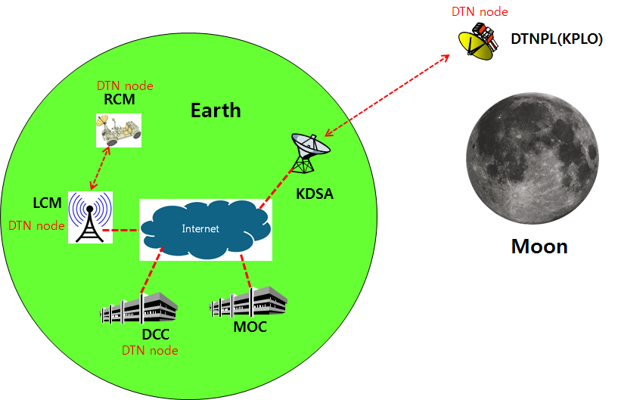
Figure 1 DTN test configuration in the first phase

Communication Nodes
Many communication nodes are needed for the DTN operation. Some of communication nodes in the network are DTN nodes whereas otherwise nodes are non-DTN nodes. The function of communication nodes used in the DTN operation is as follows.

DTN nodes
- DCC is a ground DTN node which monitor and controls DTN nodes. DCC send commands to DTN nodes such as DTNPL, LCM and RCM. It also receives telemetries or acquired data from some DTN nodes such as RCM or LCM.
- DTNPL is a DTN node mounted on the KPLO. DTNPL can be operated as a DTN end point. And it also can be operated as relay nodes which relay DTN data between DCC and RCM or LCM.
- LCM is a ground DTN node. LCM relays DTN data between MOC and RCM.
- RCM is a ground DTN node and a DTN end point. The commands sent by the DCC is terminated at the RCM and the RCM returns telemetry or data to DCC through KPLO.

Non-DTN nodes
- MOC is a non-DTN node. MOC monitors and controls KPLO and payloads. MOC also receives and processes data generated from the payloads and transfers to each payload control center.
- KDSA is a ground station for deep space communication. KDSA will have a big size of antenna and RF equipment for space link interface. KDSA also has network equipment for terrestrial communication interface such as SLE link. KDSA is a non-DTN node.

EGSE of DTN Payload

Purpose and Use
The system configuration of DTN Payload EGSE is shown in Figure 2 and has the following purposes.
- Check and verify DTN Payload function and performance during DTN Payload test.
- KPLO integrated testing and functional / performance test support.
Figure 2 DTNPL EGSE Configuration

General Capabilities
The DTNPL EGSE shall be connected to the DTNPL's electrical interface and shall be capable of testing and verifying these interfaces, and DTNPL functionality and performance testing and verification through these interfaces.
Therefore, EGSE of DTNPL should be able to do the following.
- Provides input power, On / Off control and mission profile to DTNPL under test, and controls DTNPN under test by monitoring the operation of DTNPL under test via telemetry and communication interface.
- Creates appropriate inputs to the DTNPL from the test input interface with the type, data content, data rate, and amount of data required by the particular test.
- Receive output data from the DTNPL output interface under test and provide the appropriate storage capacity required by the particular test.
- Interpretation and translation of DTNPL telemetry and dumped data should be possible.
- DTNPL provides a data processing and conversion process that simulates data transfer (including compression, encryption and formatting) and inversion of data processing (including decompression, decryption, formatting release).
- The simulated data is inverted into DTNPL input data format and data processing to verify simulated data recovered from DTNPL EGSE.

EGSE Software

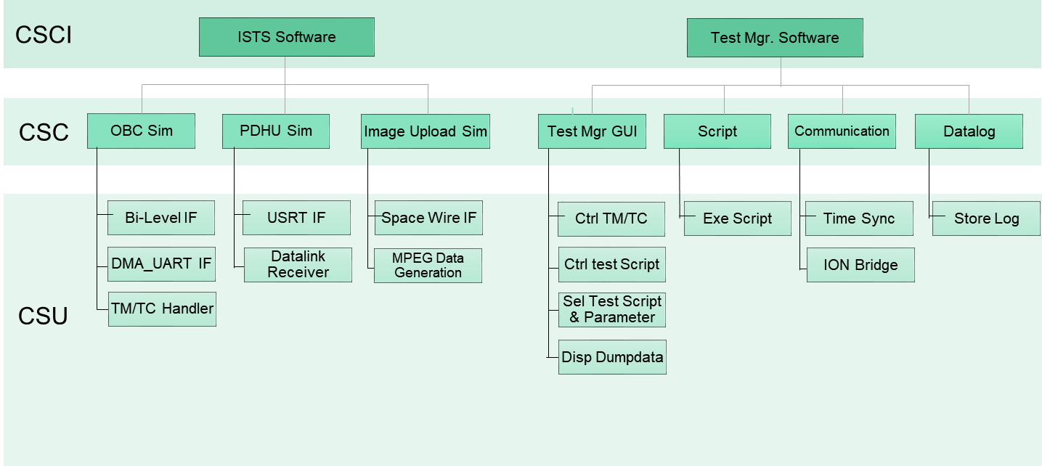
Figure 3 DTNPL EGSE Software Hierarchy

The CSCI of the EGSE software is shown in Figure 3. The CSCI is composed of ISTS software and Test Mgr. It consists of software.

COSMOS Software
COSMOS is a test manager program developed by Ball Aerospace. It communicates with ISTS software in UDP and can be used as the main GUI software of DTNPL. The characteristics of COSMOS are as follows and the program GUI is shown in Figure 5.

- The EGSE S / W tool has already been proven by many land station developers
- TCP / IP, UDP, Serial, LINC interface support
- Send commands to the test object by interface and receive and store the remote measurement values
- Scripting allows for structured / automated testing
- Consists of 14 applications

application | main function
Command and Telemetry Server | Real-time command execution, remote measurement reception, log generation limit monitoring, packet routing
Replay | Reproduce execution using log
Command Sender | Execute individual / manual commands via screen
Script Runner | Create scripts, run created scripts
Test Runner | Perform system-level tests consisting of multiple scripts, generate test reports
Packet Viewer | Defined telemetry Packet visualization, packet visualization, unit conversion for visualization
Telemetry Viewer | Remote measurement configuration display, telemetry visualization
Data Viewer | Display the value of the packet in text form and save it as a file
Limits Monitor | Remote measurement monitoring and visualization
Telemetry Extractor | Extract received remote observations, CSV Pocket Output
Command Extractor | Sent command extraction, command format output
Table Manager | Confirmation and modification of binary setting value
Handbook Creator | Describe commands and remote measurements as PDF and HTML documents
Luancher | COSMOS Application GUI

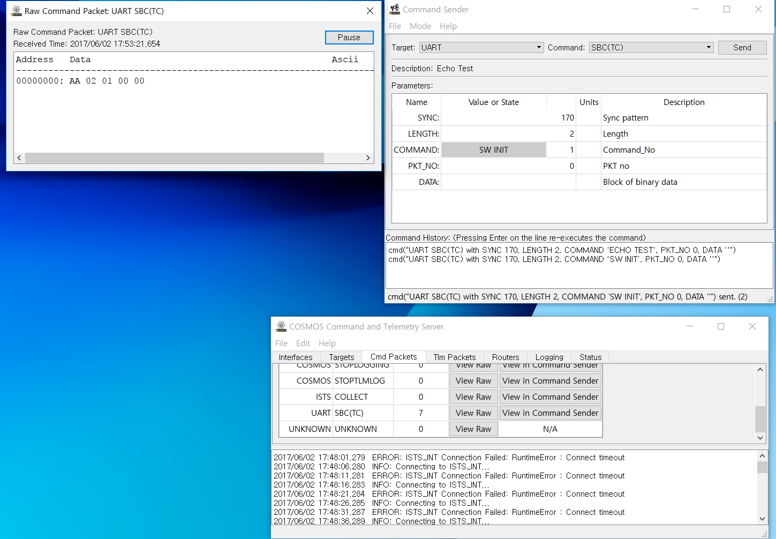
Figure 4 COSMOS GUI

Technical Description

Major Components

Facility and Peripheral Interfaces

Power Interface
The EGSE power interface is compatible with 220 V / 60 Hz (TBD) power lines without requiring the operator to operate the selector / switch. EGSE is also protected from false power applications.
The power interface must be implemented as a standard AC socket on the back panel of the EGSE. (TBD) The standard AC cable mated with the EGSE AC socket has a minimum length of 5 m. (TBD)

Internal Interfaces and Routing
The internal interface of the EGSE is connected to other components using standard cables and connectors.
All special resources designed for EGSE, such as On / Off control and telemetry collection of DTNPL under test, include control and sensing by the EGSE computer.
The signals to be routed carry out the interface through a standard coupling device. The routing design considers the tests required by the EGSE Specification and implements appropriate switching or front panel termination to support all of these tests.

DTNPL under Test Interfaces
EGSE interfaces with all electrical interfaces defined in detail in the DTNPL specification and interface control documentation. The electrical interface of the designed EGSE has the same structure as the harness, connector and contact configuration as well as circuitry compatible with DTNPL under test.
- Telemetry Interfaces
  - UART
- RS-422
- 115.2 kbps (N,8,1)
  - Bi-level
- Low: 0V, High: 5V
- Heartbeat (0.25 Hz)
- Telecommand Interfaces
  - UART
- RS-422
- 115.2 kbps (N,8,1)
  - Bi-level
- Run: 0V, Reset: 5V
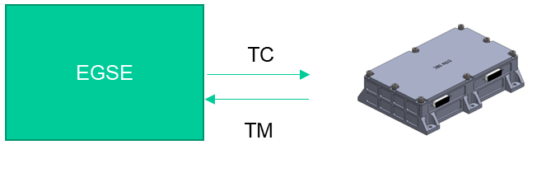
Figure 5 Telemetry / Telecommand Interfaces

- Payload Mission Data Interface
  - Image Upload
- SpaceWire RMAP
- 40 Mbps (TBR)
  - Image Download
- USRT
- 2.0 Mbps (TBR)

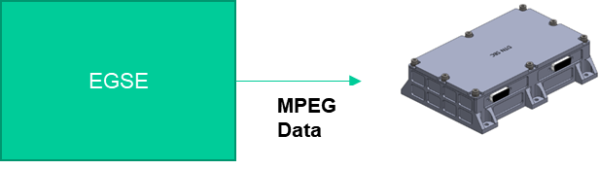
Figure 6 Image Upload for Payload Mission Data Interface

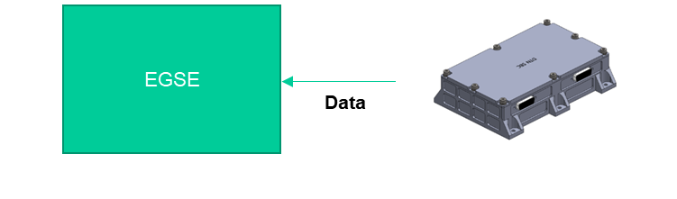
Figure 7 Image Download for Payload Mission Data Interface

Man-Machine Interface (MMI)
EGSE provides computerized MMI based on Graphic User Interface (GUI). The MMI structure performs design when the specification of EGSE is defined. (TBD)

Network Interface
EGSE is integrated with network interfaces for file transfer and remote control by standard application programs such as PC Anywhere. The network interface is a Fast Ethernet (TBD) interface terminated with an RG-45 (TBD) socket on the back panel.

Computer
The computer used in the EGSE configuration is implemented as a commercial standard PC in a rack-mount housing, with the following features and capabilities.

Case, Back-Plane, CPU and Memory
Computer case and back-plane, CPU and memory performance are as follows.
part | manufacturer | model name | Performance and Standards
CPU (TBD) | Intel | Kaby Lake | I7 7700K 4.2GHZ
RAM (TBD) | Samsung | PC4 19200 | DDR4 16 G Byte
case (TBD) | 3RSYS | J400 | WⅹLⅹH: 194ⅹ466ⅹ437 (mm)

Storage Drives
The system disk is a RAID system with mirroring capability and consists of an additional replaceable system disk. (TBD) can also be tested and stored based on sufficient storage space of 1T Byte (TBD).

Back-up Drives
EGSE has a CD-ROM / DVD-ROM writer to back up test results and event logs. It also provides a fast and reliable external data backup system, such as a USB external storage device, for copying test data.
part | manufacturer | model name | Performance and Standards
DVD-ROM (TBD) | HP | 461644-932 | 8 ⅹ 12.7 SATA

Mouse and Keyboard
EGSE connects to the computer using a wired mouse and keyboard.
part | manufacturer | model name | Performance and Standards
mouse (TBD) | Logitech | G102 Prodigy | Input signal 1ms
keyboard (TBD) | Logitech | G413 CARBON | WⅹLⅹH: 132ⅹ445ⅹ34 (mm)

Printer Interfaces
The printer interface is implemented via an Ethernet or USB interface on the EGSE back panel.

Monitor
The EGSE monitor uses a standard color monitor and displays all the major telemetry and control buttons required to operate the DTNPL. Considering the scalability of dual or triple monitors considering the copying and expansion of the display.
part | manufacturer | model name | Performance and Standards
monitor (TBD) | LG | 32MP58HQW | resolution: 1920ⅹ1080
Video card (TBD) | ASUSTek | GeForce GTX950 | Memory 2GB

Software

Operating System
EGSE computer uses MS Windows 64 bit based operating system.

MMI and Operational Software
EGSE MMI and operating software are executed by or EGSE.

Test Management and Test Programs
EGSE software manages all operations as well as the operating environment and MMI. Test and test management is performed using the COSMOS program installed in the EGSE. (TBD) COSMOS supports telemetry, event logs, progress reports and test results required for DTNPL testing. The data flow from COSMOS is as follows. (TBD)

Test Equipment
The test equipment and power supply communicate with the EGSE computer via standard bus and protocol and include the BIT function. (TBD)

Power Supply
The main power panel designed for EGSE controls the power supply to the EGSE and includes safety functions for the power supply. The standard power supply also distributes internal power.

Connectors
The connectors between DTNPL and EGSE use MIL grade or standard commercial connectors. The connector at the test end of the EGSE cable is the MIL grade (or standard commercial provided with space grade) and is matched under the DTNPL test connector as follows. (TBD)

External Cables
The cables included in the DTNPL EGSE cable set include shielding and wiring structures and are terminated with a straight-through interface at both cable ends, unless the user can easily connect them. In addition, all cables have a length of more than 5m (TBD) and are marked as follows. (TBD)

Operational Characteristics

Standby Mode
Standby mode has SBC Booting function and hardware check function, and when it is nominal, it switches to Operation mode. The resulting user sequence diagram is as follows.

Figure 8 User Sequence Diagram of Standby Mode

Operation Mode
Operation mode has ION Mission Operating (Heartbeat: 0.25 Hz) function, and Abnormal switch to Standby mode. (Heartbeat: 0 Hz)
The resulting user sequence diagram is as follows.

Figure 9 User Sequence Diagram of Operation Mode

